My painstaking search to trace the origins of the shoey

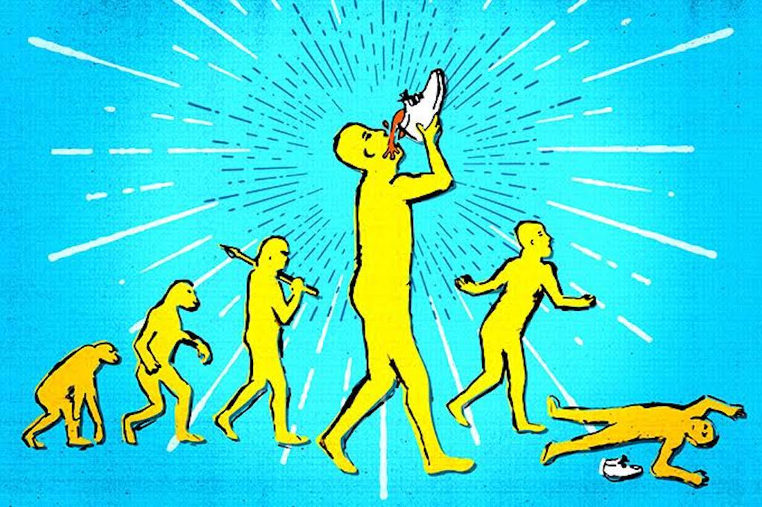

BY KATIE CUNNINGHAM
7 March 2017

This article very nearly didn’t happen.

Let me set a scene for you: late last year I was lying poolside at a resort in Fiji, trying to read but getting distracted by a group of guys who’d flown in for a festival. It was mid-afternoon and they were all totally plastered: climbing on each other’s shoulders, chanting loudly and trying to get anyone who came within a ten metre radius to join them. They were also chugging warm beer from a shoe, with half the liquid missing their mouths and splashing into the pool below.

“Shoey, miss?” they yelled out from the other side.

“No thanks,” I replied curtly, pushing my sunglasses further up my nose in a huff and picking up my phone to do what any petty, mildly-irritated millennial would: subtweet.

Obviously this wasn’t the first time I’d encountered a shoey. In 2016, the act of drinking from a shoe had become ubiquitous at festivals – at the event in Fiji, punters would approach the DJ booth with a shoey already poured, a new age devolution of the pagan offering to the gods. (The success rate was mixed: “Fuck off, I’m not doing your fucking shoey,” I saw Paces yell back into the mic at one point.)

Dillon Francis had done one. Motosports stars were obsessed with them. By then, the shoey had already caused a major diplomatic incident when a group of Australian men dubbed the Budgie 9 stripped down to their speedos at the Malaysian Grand Prix and skulled beers out of their shoes.

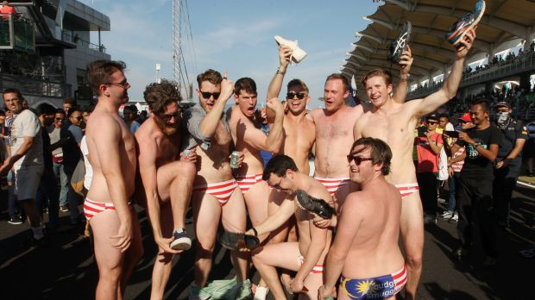

Though they’d been kicking around for a while, Google reveals that public interest in the shoey spiked in October 2016:

So I guess I shouldn’t have been surprised when it turned out that people were actually interested to find out where the fuck Australia’s latest cultural phenomenon came from.

For the rest of my Christmas break, the shoey question nagged at the back of my mind: where did it come from? Then the New Year started, I went back to the office, and the most important work of my career began.

Almost two months later, I’m ready to share what I’ve learned.

But it turns out the shoey origin story doesn’t move in a straight line: it’s more like a big knotted ball of wool, with some threads that lead to nothing, others that go around in circles and plenty that refuse to untangle. Somewhere deep in the centre is the answer, but getting there requires a lot of unravelling.

So begins one woman’s journey to the centre of the shoey.

“The punks started it”

Back when I subtweeted about the guys in the pool, someone gave me my first lead:

So I hit up a friend who’d spent a lot of time in the punk scene, and he pointed me in a direction many others would too: south. Like, all the way to Tasmania south. Shoeys definitely originated in Tassie, he said, and lore had it that St Helens punk band Luca Brasi were responsible. He also offered these words of encouragement to budding shoey-ists:

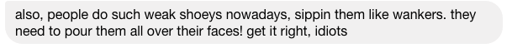

He advised me to email a publicist who specialises in rock and punk. I got this back:

“Hey Katie,

I’m fairly sure the shoey originated in Tassie. I first heard of people doing them at Luca Brasi shows but I can’t get the band to comment unfortunately.”

With that, I’d hit my first roadblock. Luca Brasi didn’t want to speak to me. But everywhere I looked, and everyone I spoke to, pointed me in their direction.

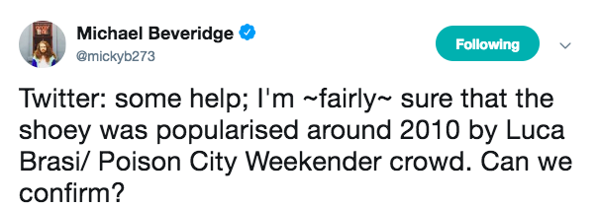

I approached their manager, who informed me that while it very much used to be their “thing” circa 2011, the Luca guys had now left the shoey firmly in the past. Well, fuck.

Instead, I chased other shoey flagbearers. I’d dug around and found an old an old Mess + Noise review that happened to include mention of the Smith Street Band frontman Wil Wagner doing a shoey on stage at Big Day Out in 2013. Their publicist confirmed that the Smith Street Band had got the shoey from Luca Brasi. Wagner agreed to speak to me on the phone, but never called.

Just when I thought the search had stalled again, I had a breakthrough. A contact in Tasmania had put me in touch with a publican known simply as Gibbo. Gibbo ran a venue in Hobart called The Brisbane Hotel, which Luca Brasi happened to frequent in their early days.
Gibbo, as it turns out, is a top bloke.

I emailed him at 5.30pm asking if he’d like to involved in an article about the origin of the shoey, and he got back to me within 20 minutes.

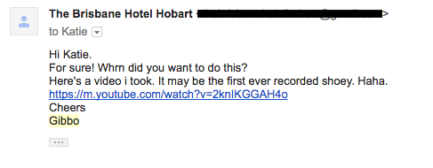

The video was uploaded in mid-2010 and boasts just 234 views:

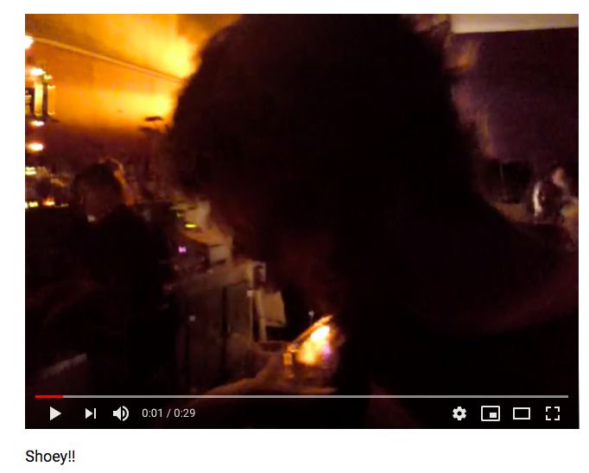

https://www.youtube.com/watch?v=2knIKGGAH4o

“It was the end of the night and there was a load of plastic, glass, bottles and filth everywhere. This dude, Jimmy K, had lost his shoe for the night and then found it amongst all the rubble of the floor,” Gibbo explained to me on the phone later.

“I was like ‘Now you’ve found your shoe you’ve got to celebrate with a shoey, mate.’ He was like, ‘Yeah, bloody oath.’ Filled up his shoe, it was a rotten looking thing. There was sweat, dirt. Filled it up and he skulled it down and the video speaks for itself.”

Gibbo also tells me that the video was filmed at a Strung Out and Loved Ones tour in June 2010, which was the first time he’d seen someone do a shoey. On support that night? A local band called Your Demise, the line-up for which featured two members – Danny Flood and Patrick Marshall – who also played in Luca Brasi.

So does that mean it all began at The Brisbane Hotel?

“That was certainly one of the places,” Gibbo says, also namechecking Launceston’s Batman Fawkner Inn. “Bands would come and play and it was like ‘Oh, we’re playing at The Brisbane, you’ve got to have a shoey.’ People started bringing in their own boots.” From there, he says, bands like Luca Brasi and Uncle Geezer spread it around Australia when they went on tour, at festivals like Poison City Weekender.

By now, I felt like I had it pretty well established that Australia’s shoey fetish first boiled up in Tasmania with Luca Brasi. But where did they get it from?

Surfies and shoeys
Around the same time I’d started chasing Tasmanian punks, I’d also hit up local promoters BBE.

The first time I’d ever heard of a shoey was January 2015, when Dillon Francis did one on stage at Field Day in Sydney. BBE head booker Anand Krishnaswamy even donated his brand-new size 12 Nike Roshe to the cause, so I hit them up to ask where the L.A. showman had discovered the shoey.

A couple weeks later, an email from Dillon himself came in:

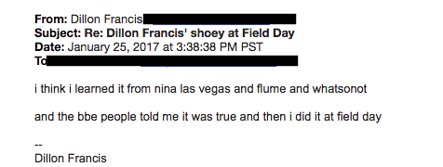

Jack Bennett, the photographer on tour with Dillon at the time, remembered the DJ was trying to find “really Australian things he could do or say.” It’s possible Jack and Sydney DJ Joyride told Dillon about shoeys.

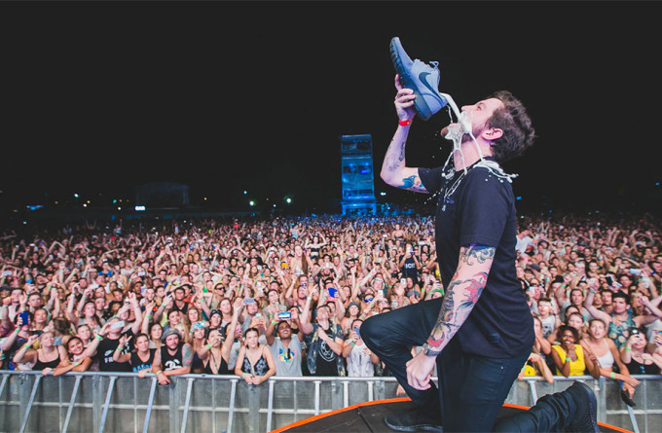
Photo credit: Jack Bennett

When I asked Jack how he learnt the craze, he pointed to the Mad Hueys.

The Mad Hueys are a crew of surfing, fishing and drinking-obsessed lads led by Shaun and Dean Harrington, two twins from Coolangatta in Queensland. They’re also early proponents of the shoey – back in 2010, they made a video for surf brand Rusty called Cop It that was full of their mates doing shoeys out of chunky mid-noughties skate shoes.

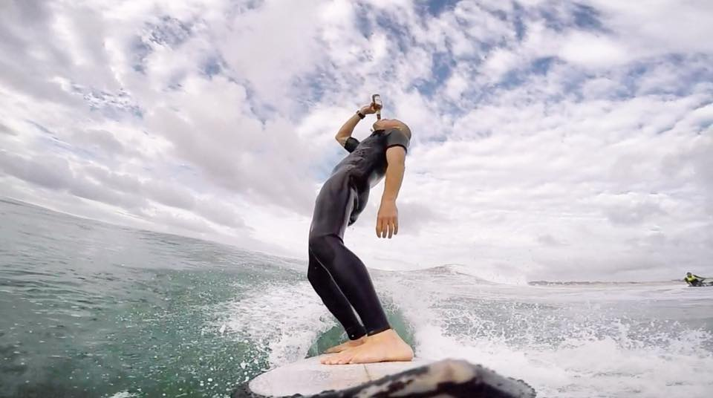
Sometimes the Hueys surf *and* drink at the same time

In June 2016, The Hueys passed the shoey to Australian MotoGP rider Jack Miller, who passed it to Formula 1 driver Daniel Riccardio, before Italian motorcycle racer Valentino Rossi (whose Facebook page boasts 13 million fans) picked it up and did it on stage at the San Marino GP in September 2016.

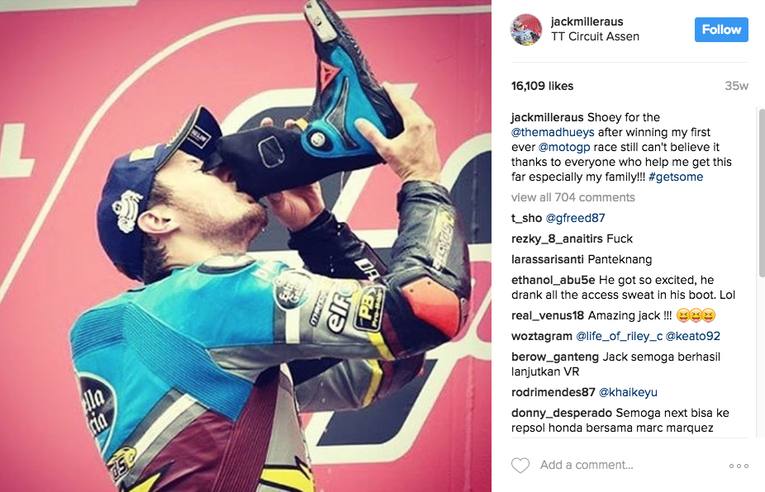

Things would have got very easy here if I could just prove that Luca Brasi picked up the shoey from the Mad Hueys – problem was, the timeline didn’t really add up.

Gibbo’s video of the “first ever recorded shoey” was filmed in June 2010, but the Huey brothers’ Rusty video didn’t come out until August 2010. Clearly, the punks didn’t start pouring VBs in their shoes after watching the Cop It clip.

But they did, apparently, get it from a different kind of surf movie. Luca Brasi’s manager told me that he believed “their whole group of friends picked it up from old bodyboarding and skate movies. I’m tipping the classic Tension series.”

Tension, I soon found out, was a series of Jackass-inspired DIY movies by a group of young guys in Perth. I dug through all the hour-long Tension movies available on YouTube, looking for an early glimpse of footwear as a drinking vessel. This took hours. Hours. My brain liquefied during this process. And you know what? I didn’t find anyone doing a shoey.

Here they are, farting in each other’s faces

I even tracked down the number of the guy who’d made the series and called him to ask if he’d ever put footage of a shoey in his movies. He didn’t pick up. Or write back to my text. Or Instagram DM.

I was at another dead end.

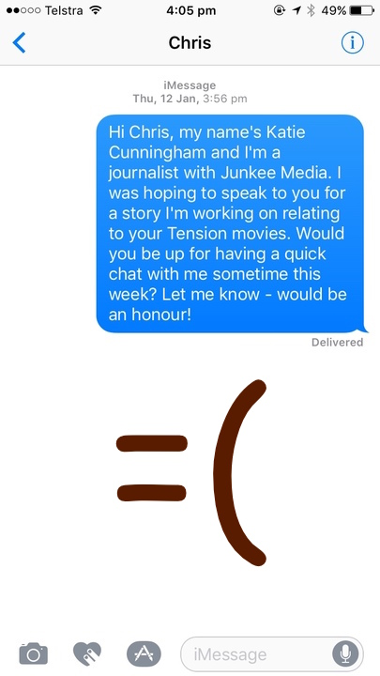
I swear guys usually text me back

But wait, there’s more
But it turns out that this shoey thing goes way, way deeper than I ever could have ever imagined.

During our chat, Gibbo from The Brisbane Hotel told me about a running club called the Hash House Harriers (The HHH), whose “down down” ritual was basically a shoey by another name: if members were spotted turning up to a run in new sneakers, they’d have to scull a beer out of their shoe as “punishment”.

All members of The HHH are given nicknames, which is why the representative I spoke to only identified himself as – umm – “Bushbasher”. According to Bushbasher, the HHH had been drinking beers out of their shoes since the 1930s, and had picked the tradition up from ex-British Military folk after the First World War.

Here’s some other things I learnt: Queensland youths in the mid-90s used to fill their RM Williams’ with beer or rum for games of ‘Shoot The Boot’. Meanwhile, the Germans have a tradition of chugging from boots that dates back to the mid-1800s, and some historians think the idea that drinking from a shoe can bring good fortune dates back to the Middle Ages.
By now I was feeling pretty jack of this whole shoey business, but I hadn’t yet tried the Mad Hueys directly. Could the Cop It creators hold the key to the timeline?

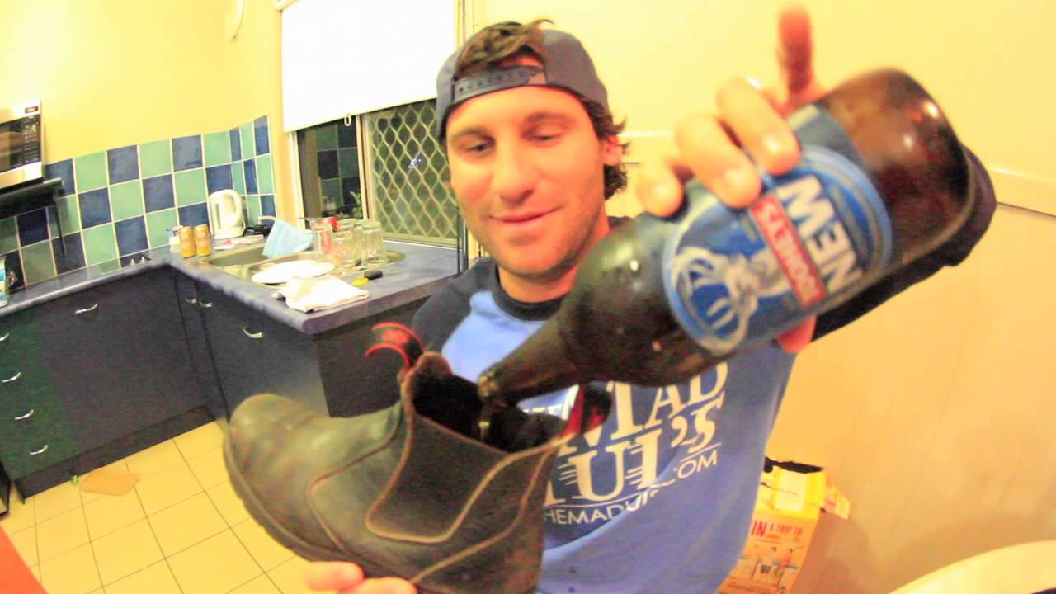

As it turned out, the pair’s Shaun Harrington was pretty easy to get on the phone.

“So I’ve been working on this story for like, two whole months,” I told Shaun after a deep breath, “but I think I’m missing a piece of the puzzle that you might be able to help me fill.” I launched into the twists and turns of my search, from the Tasmanian punks right up to the elusive surf movie that could’ve started it all. Did the Mad Hueys pick it up from a movie, and if so what was its name?

There was a long pause on the other end of the line.

“Naaaaah. The shoey was handed down by our ancestors,” Shaun laughs. “I don’t even know hey, it just came about. People have been doing them for years.”

“So do you know what year you would have started doing them?”

“I wouldn’t have a clue, but it was when I was 15 I guess.” (Shaun’s 30 now, which would mean he’s been drinking from shoes since 2002.)

“Did you ever watch the Tension movies?”

“Yeah! I’m friends with one of the boys who owned it, Chris White. He’s a legend.”

“Do you know if they ever did shoeys in those movies?”

“Nah, I don’t think they did ever.”

This went on for a while. Ultimately, though, Shaun couldn’t remember where the shoey came from, or exactly when he started doing it, or why. I felt my two-month search coming to a grinding halt.

“Sorry I couldn’t help,” Shaun said finally, seeming to sense my imminent meltdown. “Just make something up. I reckon just say it’s been handed down by our ancestors.”

Fuck it, that will have to do.

